  - Charter Schools

Desegregation Order Action and Sustainability Plan
  - 2022-2023

Charter School: Imagine South Vero Quarter of the School Year: Quarter 4 (03.27.23 - 05.31.23)

  - In August 2021, the School District of Indian River County initiated the implementation of the 2021-2022 African American Achievement Plan. To review and ensure compliance with progress of action steps associated with the African American Achievement Plan, the District provides quarterly updates related to action steps accomplished and quarterly outcomes.
  - This report is being provided by the as a comprehensive status update pursuant to the required goals in accordance with the Joint Plan for the Achievement of Unitary Status in the matter styled Sharpton, et al. v. School Board of Indian River County, FL, No. 1:64-cv-00721 (S.D. Fla.).
  - To support ongoing accountability of action step implementation, documentation, and progress the following assurances have been verified by the principal of each school:
- Action steps have been implemented with consistency and purpose to eliminate the achievement gap.
- Progress related to action steps has been monitored at designated intervals (e.g., monthly, quarterly) outlined in the African American Achievement Plan.
- Data reviews have been conducted to identify areas of strength and concern and disaggregated data will be provided upon request.
- Progress related to the elimination of the achievement gap has been monitored in an ongoing way and needed modifications have been made as identified.

Quarterly Reflection
  - (Please summarize any reflections based upon action step implementation for the quarter. What are areas of progress or opportunities for growth? What are next steps based upon work accomplished?)
Schoolwide reading proficiency as evidenced by the Spring STAR Reading assessment is 69% and 66% as evidenced by the Spring FAST Reading Assessment. Reading proficiency of African American students is 59%. The current Reading learning gain is 1.04. Schoolwide Math proficiency as evidenced by the Spring STAR Math assessment is 69% and 72% as evidenced by the Spring FAST Math Assessment. Math proficiency of African American students is 44%. The current Math learning gain is 1.03. Identified students that did not make adequate progress and/or are below grade level were invited to participate in summer learning sessions. Sessions include targeted instruction in reading and math. Furthermore, all students have access to AR, Freckle, and IXL over the summer months to read and test based on their own ZPD level as well as practice standards based on their individual needs.
These assurances have been reviewed by and verified on:
  - Name: Lauren Poirier Date: 6/7/2023

Summary
 | Key Action Steps | Commitment to Sustainability
Section II – Mentoring of New Teachers and Instructional Staff | Imagine Schools at South Vero provides support to all new teachers and instructional staff through a 3-year new teacher program. All teachers are paired with a mentor, participate in a monthly new teacher roundtable, and receive one on one coaching through coaching cycles provided by our school academic coach and academy peer coaches. Additionally, all new teachers have the opportunity to participate in Imagine Schools new teacher course (NEWT1701) provided by Imagine Schools National Academic team. Furthermore, they are evaluated and provided with feedback from the school leader using the FCPCS Observe for Success observation tool.  Q4 Update: The PD Council representative held monthly meetings as a support system to all new teachers. The school leader provided specific feedback related to the indicators within he FCPCS Observe for Success observation tool. | Imagine Schools at South Vero’s mentor program will be tailored to meet the individual needs of each new teacher; it will be structured to assist new teachers with any area of their work. The mentoring for all new teachers, including African American teachers, will address their individual needs.  Q4 Update: All new teachers continued to meet with their mentor. A Mentor Newsletter with areas of focus guided their meetings and areas of support. Mentor teachers logged their hours and checked in with the PD Council representative frequently. Teacher individual professional development plans also guided support efforts. The school year ended with a listening tour from the principal to seek input on the school year and our onboarding process to ensure our efforts are intentional based on the needs of new staff. Furthermore, the school leader conducted end of year meetings to evaluate teacher progress related to their IPDP goals and teacher evaluation ratings.
Section III - Strategies for Recruitment of African American Teachers | Imagine Schools at South Vero made initial contact in the 21-22 school year to colleges in the state of Florida. We currently have a document used within our Imagine Schools Southeast Region that is used by all school leaders to track colleges, contact information, career fair descriptions, and responses for recruiting purposes. Colleges include Historically Black Colleges and Universities. Due to COVID-19, recruitment did not occur in person; however, we did participate in virtual career fairs. Our region HR coordinator in conjunction with the school site HR coordinator will continue to establish relationships with career placement officers. If a potential candidate does not live in the surrounding area, efforts will be made for them to visit. We are in the process of connecting with Indian River State College to determine opportunities for partnership with their teaching program as well as local high schools to determine possible students interested in the career path of education. Imagine Schools at South Vero does not have a teachers’ union; however, will seek advice and ask for support from Imagine Schools national team to facilitate employment of African American teachers and other instructional staff. Imagine schools does not collect information regarding race on its Employment Application. On the application, Imagine Schools states, “We are an equal opportunity employer, and all qualified applicants will receive consideration for employment without regard to race, color, religion, sex, pregnancy, national origin, ancestry, citizenship, age, marital status, disability, veteran status, sexual orientation, gender identity, genetic information, or any other basis protected by law. This commitment extends to all aspects of employment, including but not limited to: advertising or solicitation, recruiting, hiring, placement, promotion, accommodation, transfer, demotion, compensation, training, layoff or termination, participation in social and recreational functions, and use of employee facilities.” Interview teams consist of the principal, school leadership team, teachers, and other stakeholders if applicable.  Q4 Update: A recruitment team was developed and has interviewed possible candidates for the 2023-2024 school year based on the needs of the school. Although we are seeking a diverse pool of applicants, we have not received any applications from African American candidates. | Imagine Schools at South Vero will utilize appropriate strategies and seek methods in attempting to recruit and employ African American teachers and other instructional staff. We will explore the Indian River NAACP and www.diversityrecruitmentpartners.com. Intentional efforts will be made by our recruitment team to visit colleges, universities, and career fairs in person this school year. We look forward to feedback from the SDIRC that will lead to compliance.  Q4 Update: The school leader signed a student teaching agreement with Indian River State College. Furthermore, recruitment measures were conducted at the Education Career Fair in Orlando on April 7.
Section IV – Representation of African American Teachers and Instructional Staff | Imagine Schools at South Vero indicates employment opportunities on its school website. We seek to represent employees of all races. The school does not currently maintain information regarding each teaching and instructional vacancy, including the race of each applicant and/or person hired.  Q4 Update: The school keeps record of all employee information including race. This information is updated as needed and shared with the school district. The school does not currently have any African American teachers or instructional staff. Vacancies have been posted on the school website and social media page. | Imagine Schools at South Vero will document information related to the percentage of African American teachers and instructional staff at the elementary and middle school level. Furthermore, we will continue to find avenues to share information and seek African American candidates.  Q4 Update: The school continues to record and update employee information including race.
Section VI – African American Student Achievement / Resource Allocation | Imagine Schools at South Vero collects, tracks, and analyzes student achievement data including Renaissance STAR Reading & Math and state assessment scores. This data is desegregated by grade level, teacher, gender, and race. During quarterly data chats, problem solving teams establish priority areas and action steps. Teachers meet with the data/intervention coach monthly to discuss progress of priority areas (goals) and action steps. Action steps include intervention and support specific to each student’s needs.  21-22 State Assessment Data indicates African American Students are 69% proficient in ELA and 46% proficient in Math.  Imagine Schools at South Vero’s Renaissance STAR Baseline Data indicates that the Reading predicted proficiency rate of  female African American students is 57% and 55% for African American males. For Math, the predicted proficiency rate of female African American students is 57% and 55% for African American males. Current barriers include parental involvement and fidelity of practice through homework at home.  22-23 S.M.A.R.T Goal  By the end of the school year, 70% of African American students will be at a Proficient Level or higher, as measured by the Reading State Assessment.  By the end of the school year, 55% of African American students will be at a Proficient Level or higher, as measured by the Math State Assessment.  Priority Area Action Steps Tools/ Resources Timeframe Person Responsible Evaluate  Data Driven Instruction Lead Planners guide teachers to unpack new B.E.S.T. benchmarks and align resources for small group instruction appropriately to meet the needs of all students based on their data. Wit & Wisdom Reflex Lexia Freckle Study Island STEMscopes Weekly Teachers Lead Planners Team Leads Admin STAR FAST  Q4 Update:  Schoolwide reading proficiency as evidenced by the Spring STAR Reading assessment is 69% and 66% as evidenced by the Spring FAST Reading Assessment. Reading proficiency of African American students is 59%. The current Reading learning gain is 1.04. Schoolwide Math proficiency as evidenced by the Spring STAR Math assessment is 69% and 72% as evidenced by the Spring FAST Math Assessment. Math proficiency of African American students is 44%. The current Math learning gain is 1.03.  Spring STAR Reading Predicted Proficiency  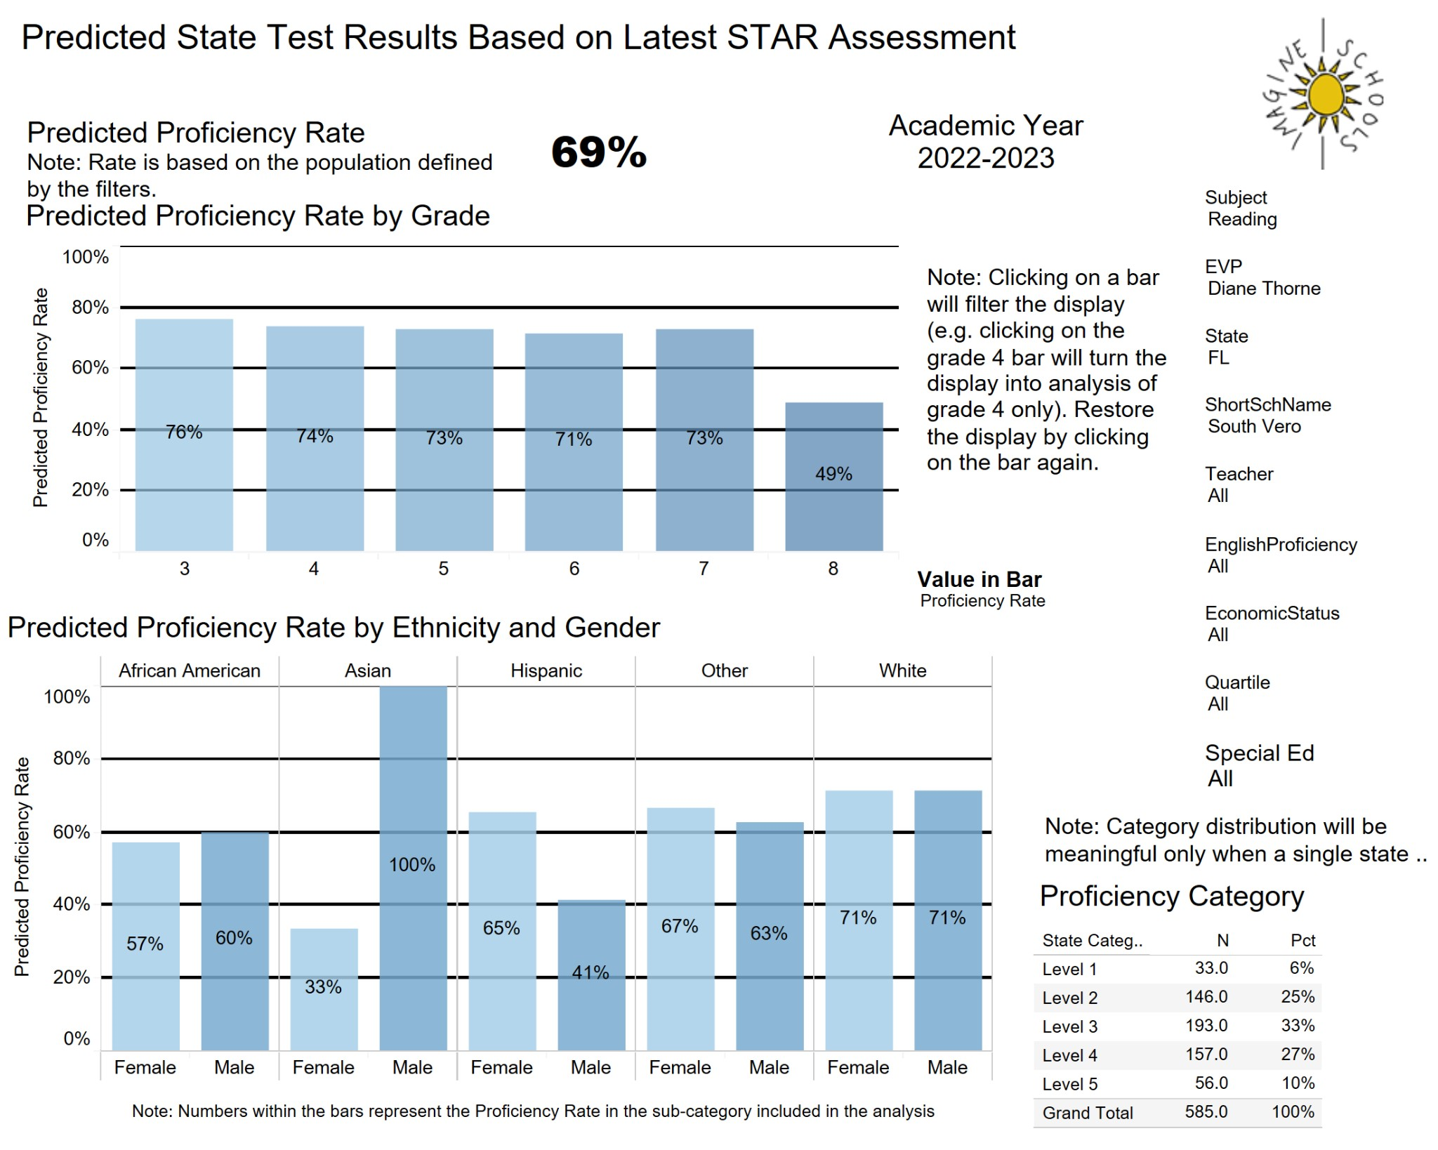  Spring STAR Math Predicted Proficiency  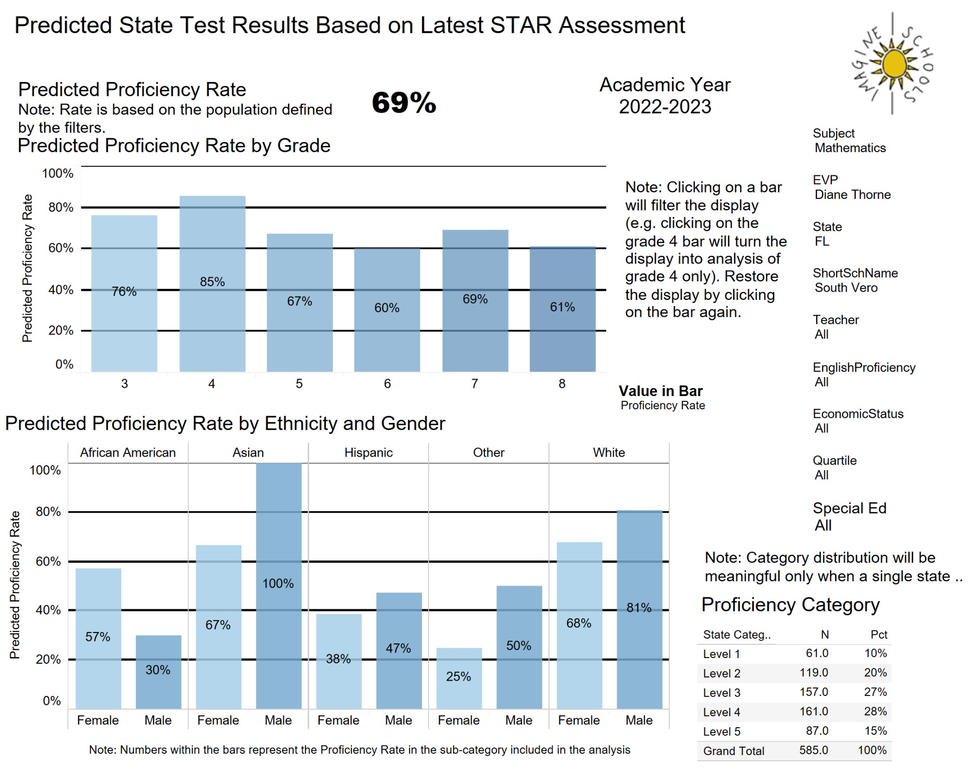  Identified students that did not make adequate progress and/or are below grade level were invited to participate in summer learning sessions. Sessions include targeted instruction in reading and math. Furthermore, all students have access to AR, Freckle, and IXL over the summer months to read and test based on their own ZPD level as well as practice standards based on their individual needs.  Extended Summer Learning (invite only)  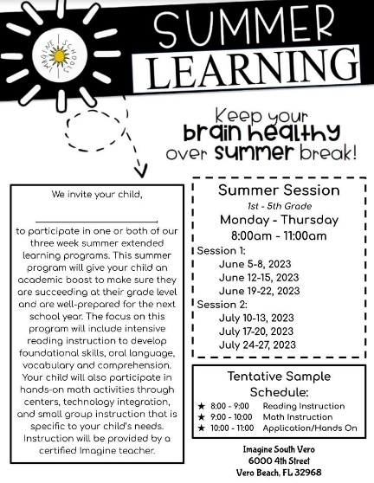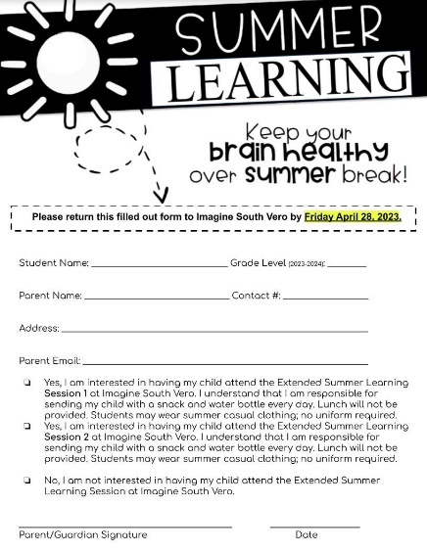  Summer Learning (all students)  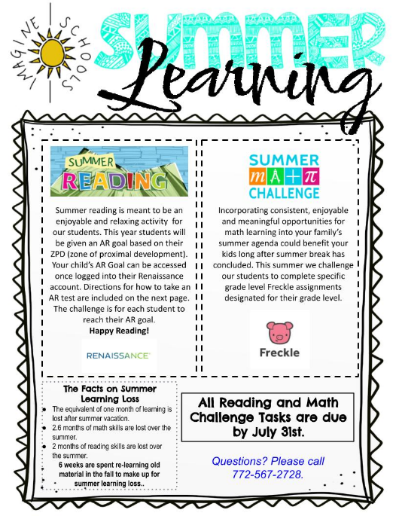  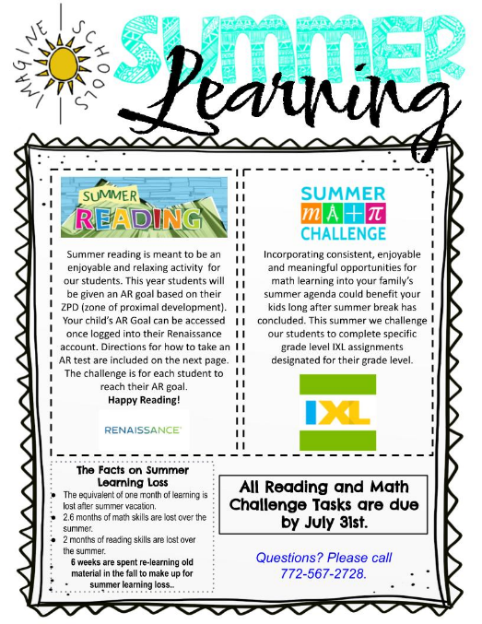  Students in Grades K-2 Students in Grades 3-8  Discipline data does not include African American students as they do not currently have any referrals, restorative conferences, or suspensions. | Imagine Schools at South Vero will closely monitor the progress of the action steps associated with the 22-23 priority area. Instruction will be tailored to the specific needs of African American students.  Q4 Update: The school leadership team met and performed an analysis of STAR and FAST Spring data to include notices & wonders. Each grade level and teacher were looked at. Key action steps were developed. Furthermore, the school leadership team met with Imagine’s region team to analyze data and determine whether the school met their academic goals outlined in the School Excellence Plan.
Section VII – Student Assignments | Imagine Schools at South Vero follows a school lottery system. All students in Indian River County have the opportunity to attend the school. Prospective Family Nights provide information regarding the school. The enrollment process and applications are available on our website as well as in the front office. In the 21-22 school year, the school held a Prospective Family Night at the Gifford Youth Achievement Center with the intention of building partnerships and providing information and applications to the Gifford and surrounding area community.  Q4 Update: The school completed its lottery and has enrolled students for the 2023-2024 school year. Any African American students who applied were enrolled based on available seats bringing our percent of African American Students from 5 to 6.7. Our current waitlist is 412 students. | Imagine Schools at South Vero will continue to find outlets to build community partnerships and provide families in Indian River County with the opportunity to attend the school. We look forward to feedback from the SDIRC on specific action steps that will lead to compliance.  Q4 Update: The school leader is continuing to partner with various community representatives to seek advice and develop intentional action steps for recruitment of African American instructional staff and students.
Section VIII - Transportation | Imagine Schools at South Vero does not currently own a bus or operate a bus route.  Q4: The school leader met with Imagine’s Southeast Region team to discuss compliance of the order and transportation opportunities. | Q4: The school is currently looking into options and opportunities for transportation for the 23-24 school year and beyond.
Section IX - Extracurricular | Imagine Schools at South Vero strives to provide all students with an environment in which students can grow and challenge their understanding of themselves as individuals and community members. While not all students can participate on every team, many opportunities are offered so that each student who desires to participate will have a chance to represent Imagine South Vero. Students will be challenged to learn new skills, to appreciate teamwork and cooperation, and to share in the fun and challenges of competitive play. Additionally, students will get the opportunity to experience competition that is sportsmanlike and respectful. The goal of our competitive teams is to play our best every game. We want all of our athletes to have a positive experience and we work toward this by setting clear guidelines, goals and expectations for our athletes, parents, and coaches. All families are informed of athletic opportunities throughout the school year. Student participation is collected and tracked by grade level and race.  Q4 Update: Sports offered to date include: flag football, baseball, K-1 soccer, and K-3 fitness Fridays. | Imagine Schools at South Vero will continue to offer extracurricular opportunities to all students as well as track participation by grade level and race for each after school sport and club.  Q4 Update: All students continue to have opportunities to participate in extracurricular activities.

Section II – Mentoring of New Teachers and Instructional Staff
The District will continue its plan and practice of welcoming and providing a supportive professional environment for all its employees, including African American employees of the School District and its schools. The current new teacher mentoring program is discussed during the new teacher orientation conference, which new teachers attend. All teachers who are in years one through three of their teaching career in Indian River are automatically enrolled in the program. The program is coordinated by the district level Professional Development (“PD”) Specialists. Additionally, each school will have a PD Council [“PDC”] representative on site who offers new teachers support, and each new teacher will be provided with a mentor who also works at his/her school.

The mentoring program will be tailored to meet the individual needs of each new teacher; it will be structured to assist new teachers with any area of their work. The mentoring for all new teachers, including African American teachers, will attempt to address their particular circumstances. [Joint Plan at 3].

Outcome Measures
 | 1993-1994 | 2005-2006 | 2014-2015 | 2017-2018 | 2018-2019 | 2019-2020 | 2020-2021 |  | 2021-2022 | 2022-2023
Count of employees participating in the mentoring program | The school was established in 2008. |  | The data are not available | 3 | 2 | 2 | 2 | 3 |  | 10
Count and percentage of on-site PD Council representatives |  |  | *Do not have PDC | *Do not have PDC | *Do not have PDC | *Do not have PDC | *Do not have PDC | *Do not have PDC |  | 1
Retention rates for new Black/African American teachers participating in the mentoring program |  |  | The data are not available | 0 | 0 | 0.01% | 0 | 0 |  | 0
Overall teacher retention rate |  |  | The data are not available | 84% | 91% | 91% | 81% | 84% |  | 100%

2022-2023 Outcome Measures
 | 2022-2023
 | September 2022 | December 2022 | March 2023 | June 2023
Count of employees participating in the mentoring program | 10 | 10 | 10 | 10
Count and percentage of on-site PD Council representatives | 0 | 1 | 1 | 1
Retention rates for new Black/African American teachers participating in the mentoring program | 0 | 0 | 0 | 0
Overall teacher retention rate | 100% | 100% | 100% | 100%

Section III – Strategies for Recruitment of African American Teachers
The School District will utilize appropriate strategies in attempting to recruit and employ African American teachers and other instructional staff. As an aspirational goal only, the recruitment/hiring program will seek to reasonably approximate the Florida state-wide racial composition of teachers and other instructional staff at each grade level (i.e., elementary, middle, and high school). The parties recognize that the state-wide figures are used only as an aspirational goal and may not fairly reflect the pool of applicants reasonably available for employment in Indian River County. In an effort to achieve this objective, the School District will utilize appropriate strategies in attempting to recruit and employ African American teachers and other instructional staff, including, without limitation, the following strategies:

- Using existing staff to facilitate recruiting;
- Visiting colleges, universities, and career fairs to recruit and provide offer letters of intent to potential African American teachers and other instructional staff, with such recruiting to include at least annual visits to Historically Black Colleges and Universities (“HBCUs”) in Florida (namely, Bethune-Cookman University, Florida A&M University, and Florida Memorial University), as well as the Florida Fund for Minority Teachers’ annual meeting;
- Having the School District’s Human Resources Director endeavor to establish and develop relationships with the career placement offices and officials at the HBCUs;
- Continuing to recruit at HBCUs outside Florida;
- Identifying African American high school students in the District who would make great teachers, offering the students mentors while in school, and, if they are successful in graduating college with appropriate credentials, will attempt to contact these identified students for recruitment purposes. [See page 7: https://www2.ed.gov/rschstat/eval/highered/racial-diversity/state-racial-diversity-workforce.pdf]
- Having potential African American candidates for teaching and other instructional positions visit Indian River County if the candidate so desires;
- Working with the teachers’ union to facilitate the employment of African American teachers and other instructional staff;
- Utilizing current Indian River County hiring practices of application, structured interviewing by individuals in the School District office, and interviewing by individual school principals and/or members of the School Improvement Teams;
- Listing the Indian River NAACP as a community partner on the School District’s website;
- Publicizing the program for Mentoring of New Teachers and Instructional Staff, including by posting the program on the School District’s “jobs” webpage and bringing promotional materials to recruiting events;
- Ensuring that the School District advertises teaching job openings in the Diversity in Ed Magazine and on the Diversity in Ed website (www.diversityrecruitmentpartners.com);
- Require District principals to interview, whenever possible, a diverse pool of applicants.

The School Board shall require the retention of documentation that demonstrates which strategies for recruiting and employing African American teachers and instructional staff were utilized by the School District and the individual schools each year, and shall ensure that such documentation is made available to the Equity Committee through appropriate channels determined by the School Board. Data provided shall include the dates of recruitment activities, staff members involved, recruitment event attended, investments incurred for recruiting activity/trip, and outcomes. Data should include information regarding the race and specific teacher or instructional staff position for which candidates were interviewed, extended offers, and hired. Instructional staff and teaching positions shall have the same definitions as those assigned by the Florida Department of Education. [Joint Plan at 4-5].

Outcome Measures
 | 1993-1994 | 2005-2006 | 2015-2016 | 2017-2018 | 2018-2019 | 2019-2020 | 2020-2021 | 2021-2022 | 2022-2023
Number of Career Fairs/Virtual events attended | The school was established in 2008. |  | The data are not available. |  |  | 1 | 2 | 2 | 1
Count and Percentage of HBCUs/Virtual events attended |  |  |  |  |  | 0 | 0 | 0 | 0

 |  | June 1994 |  | June 2006 |  | June 2017 |  | June 2018 |  | June 2019 |  | June 2020 |  | June 2021 |  | June 2022 |  | June 2023
 |  | Number of Applicants | Percentage of Applicants | Number of Applicants | Percentage of Applicants | Number of Applicants | Percentage of Applicants | Number of Applicants | Percentage of Applicants | Number of Applicants | Percentage of Applicants | Number of Applicants | Percentage of Applicants | Number of Applicants | Percentage of Applicants | Number of Applicants | Percentage of Applicants | Number of Applicants | Percentage of Applicants
Representation of applicants for instructional positions by race | African American | The school was established in 2008. |  |  |  | The data are not available. |  |  |  |  |  |  |  |  |  |  |  | The data are not available. | The data are not available.
 | White, Non-Hispanic |  |  |  |  |  |  |  |  |  |  |  |  |  |  |  |  | The data are not available. | The data are not available.
 | Total
 | African American/White Gap |  |  |  |  |  |  |  |  |  |  |  |  |  |  |  |  | The data are not available. | The data are not available.
Imagine Schools Employment Application does not include the collection of information regarding race. https://www.imagineschools.org/join-our-team/

 |  | 1993-1994 |  | 2005-2006 |  | 2015-2016 |  | 2017-2018 |  | 2018-2019 |  | 2019-2020 |  | 2020-2021 |  | 2021-2022 |  | 2022-2023
 |  | Number of New Hires | Percentage of New Hires | Number of New Hires | Percentage of New Hires | Number of New Hires | Percentage of New Hires | Number of New Hires | Percentage of New Hires | Number of New Hires | Percentage of New Hires | Number of New Hires | Percentage of New Hires | Number of New Hires | Percentage of New Hires | Number of New Hires | Percentage of New Hires | Number of New Hires | Percentage of New Hires
Representation of new instructional staff hires by race/ethnicity | African American | The school was established in 2008. |  |  |  | The data are not available. |  |  |  |  |  |  |  |  |  |  |  | In progress | In progress
 | White, Non-Hispanic |  |  |  |  |  |  |  |  |  |  |  |  |  |  |  |  | In progress | In progress
 | Total |  |  |  |  |  |  |  |  |  |  |  |  |  |  |  |  | In progress | In progress
 | African American/White Gap |  |  |  |  |  |  |  |  |  |  |  |  |  |  |  |  | In progress | In progress

 |  | 1993-1994 | 2005-2006 | 2015-2016 | 2017-2018 | 2018-2019 | 2019-2020 | 2020-2021 | 2021-2022 | 2022-2023
Racial/ethnic representation of Recruitment Team members | African American | The school was established in 2008. |  | The data are not available. |  |  |  |  | 0 | The data are not available.
 | American Indian/Alaskan Native |  |  |  |  |  |  |  | 0 | The data are not available.
 | Asian |  |  |  |  |  |  |  | 0 | The data are not available.
 | Hispanic |  |  |  |  |  |  |  | 0 | The data are not available.
 | Multi-Racial |  |  |  |  |  |  |  | 1 | The data are not available.
 | White, Non-Hispanic |  |  |  |  |  |  |  | 7 | The data are not available.
*Recruitment team will be established in April.
2022-2023 Outcome Measures
 | 2022-2023
 | September 2022 | December 2022 | March 2023 | June 2023
Number of Career Fairs/Virtual events attended | 0 | 0 | 0 | 1
Count and Percentage of HBCUs/Virtual events attended | 0 | 0 | 0 | 0

 |  | 2022-2023
 |  | September 2022 |  |  | December 2022 |  | March 2023 |  | June 2023
 |  | Number of Applicants |  | Percentage of Applicants | Number of Applicants | Percentage of Applicants | Number of Applicants | Percentage of Applicants | Number of Applicants | Percentage of Applicants
Representation of applicants for instructional positions by race | African American | The data are not available. | The data are not available. |  | The data are not available. | The data are not available. | The data are not available. | The data are not available. | The data are not available. | The data are not available.
 | White, Non-Hispanic | The data are not available. | The data are not available. |  | The data are not available. | The data are not available. | The data are not available. | The data are not available. | The data are not available. | The data are not available.
 | Total | The data are not available. | The data are not available. |  | The data are not available. | The data are not available. | The data are not available. |  | The data are not available.
 | African American/  White Gap | The data are not available. | The data are not available. |  | The data are not available. | The data are not available. | The data are not available. | The data are not available. | The data are not available. | The data are not available.
Imagine Schools Employment Application does not include the collection of information regarding race. https://www.imagineschools.org/join-our-team/

 |  | 2022-2023
 |  | September 2022 |  | December 2022 |  | March 2023 |  | June 2023
 |  | Number of New Hires | Percentage of New Hires | Number of New Hires | Percentage of New Hires | Number of New Hires | Percentage of New Hires | Number of New Hires | Percentage of New Hires
Representation of new instructional staff hires by race/ethnicity | African American | 0 | 0 | 0 | 0 | 0 | 0 | 0 | 0
 | White, Non-Hispanic | 10 | 100% | 10 | 100% | 10 | 100% | 10 | %100
 | Total | 100% |  | 100% |  | 100% |  | 100%
 | African American/White Gap | 100 |  | 100 |  | 100 |  | 100

 |  | September 2022 | December 2022 | March 2023 | June 2023
Racial/ethnic representation of Recruitment Team members | African American | 0 | 0 | 0 | 1
 | American Indian/Alaskan Native | 0 | 0 | 0 | 0
 | Asian | 0 | 0 | 0 | 0
 | Hispanic | 0 | 0 | 0 | 0
 | Multi-Racial | 0 | 0 | 0 | 0
 | White, Non-Hispanic | 0 | 0 | 0 | 4

Section IV – Representation of African American Teachers and Instructional Staff
The School Board shall endeavor to maintain a reasonable representation of African American teachers and instructional staff at each school compared to the percentage of African American teachers and instructional staff at the school’s corresponding level (i.e., elementary, middle, high, alternative. The District shall endeavor to employ at least one African American teacher at each elementary, middle, high school, and alternative school, the District and principals shall report on efforts to hire and/or encourage transfer to that school(s), and make such documentation available to the Equity Committee through appropriate channels determined by the School Board.

To allow the School Board to assess the reasonableness of the distribution of African American teachers and instructional staff, the Board shall:
- require the maintenance of information listing all teaching and instructional staff vacancy announcements for that school year, and shall require principals to maintain information regarding each teaching and instructional vacancy, including the race of each applicant, interviewee, person(s) selected to fill the vacancy, and person hired for the vacancy, and make such information available to the Equity Committee through appropriate channels;
- require the maintenance of information regarding the race and specific position of all teachers and instructional staff by school, and make such information available to the Equity Committee through appropriate channels; and
- require the maintenance of information regarding the turnover of African American teachers and instructional staff at each school and the reason(s) for the turnover, if known, and make such information available to the Equity Committee through appropriate channels. [Joint Plan at 5].
Outcome Measures
 |  | 1993-1994 |  | 2005-2006 |  | 2015-2016 |  | 2017-2018 |  | 2018-2019 |  | 2019-2020 |  | 2020-2021 |  | 2021-2022 |  | 2022-2023
 |  | Number of Certified Instructors | Percentage of Certified Instructors | Number of Certified Instructors | Percentage of Certified Instructors | Number of Certified Instructors | Percentage of Certified Instructors | Number of Certified Instructors | Percentage of Certified Instructors | Number of Certified Instructors | Percentage of Certified Instructors | Number of Certified Instructors | Percentage of Certified Instructors | Number of Certified Instructors | Percentage of Certified Instructors | Number of Certified Instructors | Percentage of Certified Instructors | Number of Certified Instructors | Percentage of Certified Instructors
Representation of certified instructors by race/ethnicity | African American | The school was established in 2008. |  |  |  | The data are not available. |  |  |  |  |  | 1 | 0.01% | 0 | 0 | 0 | 0 | 0 | 0
 | White, Non-Hispanic |  |  |  |  |  |  |  |  |  |  | 52 | 0.98% | 53 | 100% | 53 | 100% | 57 | 100%
 | Total |  |  |  |  |  |  |  |  |  |  | 53 |  | 53 |  | 53 |  | 57
 | African American/White Gap |  |  |  |  |  |  |  |  |  |  | 51 | 99% | 53 | 100% | 53 | 100% | 57 | 100%

2022-2023 Outcome Measures

 |  | 2022-2023
 |  | September 2022 |  | December 2022 |  | March 2023 |  | June 2023
 |  | Number of Certified Instructors | Percentage of Certified Instructors | Number of Certified Instructors | Percentage of Certified Instructors | Number of Certified Instructors | Percentage of Certified Instructors | Number of Certified Instructors | Percentage of Certified Instructors
Representation of certified instructors by race/ethnicity | African American | 0 | 0 | 0 | 0 | 0 | 0 | 0 | 0
 | White, Non-Hispanic | 57 | 100% | 57 | 100% | 57 | 100% | 57 | 100%
 | Total Number of Certified Instructors | 57 |  | 57 |  | 57 |  | 57
 | African American/White Gap | 100 |  | 100 |  | 100 |  | 100

Section V – Partial Unitary Status and Continued Plan Supervision
Based on its record of compliance with prior orders and the data and information exchanged, the Indian River NAACP and the School Board agree that the District has already achieved unitary status in the areas of facilities, non-instructional staff and administrative staff.
The parties will take all reasonable efforts to work with the Court to obtain an order of partial unitary status to that effect.
The School District will continue under this [August 2018] desegregation order while the plan developed by the parties for achieving full unitary status is implemented. This will maintain an avenue for dealing with problems should any occur in the process of implementation. This [August 2018] order will continue in effect until further Court Order. This case will remain open; the parties agree that there has not yet been a determination of full unitary status and the Court shall retain jurisdiction of this case. [Joint Plan Section at 6].

Section VI – African American Student Achievement / Resource Allocation
The goal of the School District’s African American Student Academic Achievement Plan shall be to eliminate the achievement gap as compared to white students, and the Plan shall identify barriers to the academic achievement of African American students; list the strategies, procedures, and/or programs that will be implemented to improve the academic achievement of African American students and address the identified barriers; and set measurable goals for the improvement of African American academic achievement. The School District’s African American academic achievement plan shall also address any disparate discipline of African American students and the assignment of African American students to special programs, such as the exceptional student education (“ESE”) and Alternative Education programs, including whether such assignments exceed state and district averages for other groups.

In 2016, the School District developed and implemented an African American Student Academic Achievement Plan. Prior to the start of each school year, the School Board will review the School District’s African American Student Academic Achievement Plan, consider any recommended changes to the Plan, and approve the Plan. The School Board shall ensure that the School District maintains documentation regarding the implementation of the Plan, as well as information and data sufficient to evaluate the results/effectiveness in improving the academic achievement of African American students.

The Equity Committee shall be responsible for monitoring the School District’s implementation of the Plan and the results/effectiveness of the plan in improving the academic achievement of African American students. The School Board shall ensure that information requested by the Equity Committee for accomplishment of its responsibility for monitoring the implementation and results/effectiveness of the Plan is timely made available to the Equity Committee through appropriate channels determined by the School Board in its discretion. The Equity Committee shall submit any recommendations to the School Board for modifying the Plan to eliminate strategies, procedures, and/or programs that have not been successful or to include new strategies, procedures, and/or programs likely to improve academic achievement of African American students. All recommendations provided by the Equity Committee shall be made in an advisory capacity; at all times, ultimate authority remains with the School Board and the Equity Committee has no authority to direct the day-to-day operations of the School District.

To evaluate progress, data should include student achievement data monitored in the 5 year Strategic Plan monitoring framework with demographic information for each student group. This would enable the parties to examine the residualized gain scores across the school year by race, by grade, and within schools. Discipline data is also included in the 5 year Strategic Plan monitoring framework.

In light of the above-described process and division of responsibility for addressing the academic achievement of African American students, the previously existing African American Student Academic Achievement Plan Committee is superseded. [Joint Plan Section at 6].

Outcome Measures
Florida Department of Education School Grade Comparison
School Name | 2018-2019 | 2019-2020 | 2020-2021* | 2021-2022 | 2022-2023
Imagine at South Vero | A | 2019-2020 School Grades were not issued due to the COVID-19 pandemic | A | A | Will update when we receive all data.
Indian River Charter High School | A |  | B | B
North County Charter School | B |  | C | C
Sebastian Charter Junior High School | A |  | A | A
St. Peter’s Academy | B |  | B | B
*Schools were given the option to be given a 2020-2021 School Grades due to disruptions in instruction from COVID-19. SDIRC did not elect to be given school grades. However, the data shown is what would have been earned.

Annual Outcome Measures
Achievement Gaps on Spring 2021 Assessment Results
 | 2017 - 2018 |  |  |  | 2018 - 2019 |  |  |  | 2019 - 2020 | 2020 - 2021 |  |  |  | 2021 - 2022
 | White, Non-Hispanic  (% 3+) | African American  (% 3+) | Gap | State Ranking | White, Non-Hispanic  (% 3+) | African American  (% 3+) | Gap | State Ranking | Pursuant to Florida Department of Education Emergency Order No. 2020-EO-1, spring K-12 statewide assessment test administrations for the 2019 - 2020 school year were canceled and accountability measures reliant on such data were not calculated for the 2019-2020 school year. | White, Non-Hispanic  (% 3+) | African American  (% 3+) | Gap | State Ranking | White, Non-Hispanic  (% 3+) | African American  (% 3+) | Gap | State Ranking
ELA – Grades 3-10  (Level 3+) | 69% | 55% | 14% | 47 | 73% | 67% | 6% | 47 |  | 72% | 67% | 5% | 48 | 70% | 65% | 5%
Mathematics Combined (Level 3+) | 71% | 50% | 21% | 48 | 71% | 67% | 4% | 44 |  | 75% | 63% | 12% | 46 | 74% | 46% | 28%

2022-2023 Outcome Measures

Section VII – Student Assignments
Each year, the percentage of African American students assigned to individual schools should be consistent with the percentage of African American students represented in the School District. During the 2016-2017 school year, 17.2% of students in the School District were African American. The School District will allocate student populations at each school in proportion to the percentage distribution of African American students District-wide within a range of plus or minus nine (9) percentage points. The School District needs to keep this percentage point range wide enough to satisfy natural fluctuation and to eliminate additional extensive transportation of students.

The School District will continue the practice of curricular and programmatic choice in assigning students who may reside outside an attendance area of school on a space available basis. This will allow all students to take advantage of special programs.

The Equity Committee shall be responsible for monitoring student assignments at individual schools, including student assignments based on residence within an attendance area and student assignments based on curricular and programmatic choice. The School Board shall ensure that information requested by the Equity Committee which is reasonable related to its responsibility for monitoring student assignments is timely made available to the Equity Committee through appropriate channels determined by the School Board. Data provided shall include numbers of students in each school by race. [Joint Plan at 7].

Outcome Measures
Racial Representation of Students by School (Charter Schools)
Retrieved 11/23/21 for 2017-2021; Retrieved 2/7/22 for 2021-2022, Source: Focus School Software
 |  | 1993-1994 |  | 2005-2006 |  |  | 2015-2016 |  |  |  | 2017 - 2018 |  |  |  | 2018 - 2019 |  |  |  | 2019 - 2020 |  |  |  | 2020 - 2021 |  |  |  | 2021 - 2022 |  |  | 2022-2023
 |  | African American | White, Non-Hispanic | African American | White, Non-Hispanic |  | African American |  | White, Non-Hispanic |  | African American |  | White, Non-Hispanic |  | African American |  | White, Non-Hispanic |  | African American |  | White, Non-Hispanic |  | African American |  | White, Non-Hispanic |  | African American |  | White, Non-Hispanic
District |  | After requesting historical student membership from the Florida Department of Education, the earliest report accessible is for the 1995-1996 school year. |  | 14.93% | 66.15% |  | 17% |  | 56% |  | 17% |  | 55% |  | 17% |  | 54% |  | 18% |  | 54% |  | 18% |  | 54% |  | 19% |  | 53%
CHARTER SCHOOLS
Imagine School at South Vero (ISV) | After requesting historical student membership from the Florida Department of Education, the earliest report accessible is for the 1995-1996 school year. |  |  |  |  | 1% |  | 86% |  | 3.4% |  | 65.9% |  | 3% |  | 82% |  | 4% |  | 83% |  | 5% |  | 83% |  | 7% |  | 86% |  | 5% | 84%
Indian River Charter High School (IRCHS) |  |  |  |  |  | 2% |  | 82% |  | 5.4% |  | 54.7% |  | 5% |  | 71% |  | 4% |  | 74% |  | 4% |  | 74% |  | 9% |  | 78%
North County Charter School (NCCS) |  |  |  |  |  | 0%  <10 |  | 81% |  | 11.0% |  | 44.4% |  | 11% |  | 67% |  | 11% |  | 68% |  | 11% |  | 70% |  | 13% |  | 76%
Sebastian Charter Junior High (SCJHS) |  |  |  |  |  | 0%  <10 |  | 70% |  | 3.7% |  | 39.5% |  | 5% |  | 68% |  | 6% |  | 69% |  | 7% |  | 68% |  | 8% |  | 73%
St. Peter’s Academy (SPA) |  |  |  |  |  | 82% |  | 0%  <10 |  | 49.3% |  | 7.7% |  | 50% |  | 12% |  | 51% |  | 11% |  | 48% |  | 11% |  | 54% |  | 7%
“The School District will allocate student populations at each school in proportion to the percentage distribution of African American students District-wide within a range of plus or minus nine (9) percentage points” [Joint Plan at 7]. Schools that have a student enrollment population meeting the percentage range are highlighted in green.

Section VIII – Transportation
The School District will continue to operate under the requirements of the 1967 Order (which requirements were not changed by the 1994 order) with respect to transportation, which mandate (1) no student shall be segregated or discriminated against on account of race or color in any service, activity, or program, including transportation, and that (2) where transportation is generally provided, buses must be routed to the maximum extent feasible in light of the geographic distribution of students, so as to serve students assigned in accordance with the provisions of this plan.

The Equity Committee shall be responsible for monitoring the School District’s compliance with transportation requirements. The School Board shall ensure that information requested by the Equity Committee which is reasonably related to its responsibility for monitoring student assignments is timely made available to the Equity Committee through appropriate channels determined by the School Board. Data provided shall include numbers of students accessing bus transportation broken down by student groups. [Joint Plan at 7].

Outcome Measures
Percentage of Students Within Each Racial/Ethnic Subgroup Utilizing School Transportation by School
School | February 2019 |  |  |  | February 2020 |  |  |  | February 2021 |  |  |  | February 2022 |  |  |  | February 2023
 | African American |  | White,  Non-Hispanic |  | African American |  | White,  Non-Hispanic |  | African American |  | White,  Non-Hispanic |  | African American |  | White,  Non-Hispanic |  | African American |  | White,  Non-Hispanic
 | Total Zoned Students Transported | Total School Choice Students Transported | Total Zoned Students Transported | Total School Choice Students Transported | Total Zoned Students Transported | Total School Choice Students Transported | Total Zoned Students Transported | Total School Choice Students Transported | Total Zoned Students Transported | Total School Choice Students Transported | Total Zoned Students Transported | Total School Choice Students Transported | Total Zoned Students Transported | Total School Choice Students Transported | Total Zoned Students Transported | Total School Choice Students Transported | Total Zoned Students Transported | Total School Choice Students Transported | Total Zoned Students Transported | Total School Choice Students Transported
**Imagine Schools at South Vero | 0%  (0/884) | 0%  (0/0) | 0%  (8/884) | 0%  (0/0) | 0%  (0/877) | 0%  (0/0) | 0.1%  (1/877) | 0%  (0/0) | 0%  (0/859) | 0%  (0/0) | 0%  (0/859) | 0%  (0/0) | 0%  (0/873) | 0%  (0/0) | 0%  (0/873) | 0%  (0/0) | 0%  (0/872) | 0%  (0/0) | 0%  (0/872) | 0%  (0/0)
**Indian River Charter High School | <1%  (1/693) | 0%  (0/0) | 0%  (0/693) | 0%  (0/0) | 0%  (0/687) | 0%  (0/0) | 0.4%  (3/687) | 0%  (0/0) | 0%  (0/711) | 0%  (0/0) | 0%  (0/711) | 0%  (0/0) | 0%  (0/721) | 0%  (0/0) | 0%  (0/721) | 0%  (0/0) | 0%  (0/727) | 0%  (0/0) | 0%  (0/727) | 0%  (0/0)
**North County Charter School | 6%  (22/367) | 0%  (0/0) | 11.2%  (41/367) | 0%  (0/0) | 4.9%  (19/385) | 0%  (0/0) | 11.9%  (46/385) | 0%  (0/0) | 4.0%  (15/376) | 0%  (0/0) | 9.8%  (37/376) | 0%  (0/0) | 4.5%  (17/378) | 0%  (0/0) | 8.9%  (34/378) | 0%  (0/0) | 0%  (0/286) | 0%  (0/0) | 0%  (0/286) | 0%  (0/0)
**Sebastian Charter Jr. High | 1.9%  (5/262) | 0%  (0/0) | 27.9%  (73/262) | 0%  (0/0) | 3.8%  (10/265) | 0%  (0/0) | 30.6%  (81/265) | 0%  (0/0) | 2.8%  (8/283) | 0%  (0/0) | 19.1%  (54/283) | 0%  (0/0) | 3.9%  (11/283) | 0%  (0/0) | 22.6%  (64/283) | 0%  (0/0) | 0%  (0/296) | 0%  (0/0) | 0%  (0/296) | 0%  (0/0)
**St. Peter’s Academy | 28.3%  (39/138) | 0%  (0/0) | 5.8%  (8/138) | 0%  (0/0) | 27.3%  (39/143) | 0%  (0/0) | 10.5%  (15/143) | 0%  (0/0) | 24%  (31/129) | 0%  (0/0) | 7%  (9/129) | 0%  (0/0) | 31.3%  (40/128) | 0%  (0/0) | 7.0%  (9/128) | 0%  (0/0) | 0%  (0/110) | 0%  (0/0) | 0%  (0/110) | 0%  (0/0)

*In compliance with Section 1011.62(1)(a), Florida Statutes (F.S.), requires Florida school districts to report Full-Time Equivalent (FTE) student membership by conducting periodic surveys throughout the school year. In accordance, the District reports transportation ridership data within the Florida Department of Education’s Survey 2 (October) and Survey 3 (February) reporting windows. Due to the fluctuation of ridership data during the fall Survey 2 window, as well as a subsequent correction window to verify the accuracy of survey data submitted, the District assesses transportation ridership data for the purpose of monitoring progress in relation to the 2018 Joint Plan during the February Survey 3 window.

** The SDIRC has three magnet elementary schools: Liberty, Rosewood, and Osceola. The three elementary magnet schools are filled by the choice lottery for 100% of the available student capacity. All remaining SDIRC schools are Choice schools. These schools are filled by their zoned students and 5% of their capacity is reserved for the choice lottery system. The SDIRC Magnet and Choice application is open each year from November 1 to January 15. When the application window closes, the applicants are screened for specific categories such as siblings already placed at the school, military families, and students that would assist in meeting the federal mandate of the Desegregation Order and the 2018 Joint Plan. The lottery is typically held on January 31. Once families receive their offers, seats that are not accepted by families are then filled in a second lottery run. The Magnet and Choice application is re-opened after the lottery for the remainder of the year.

*** Please note that charter schools are responsible for arranging school transportation for their school site. Imagine Schools at South Vero and Indian River Charter High School do not provide school transportation. Additionally, Charter Schools are run by independent governing bodies, and the SDIRC is not involved in their application process. The SDIRC did inform the charter schools that the Federal Desegregation order takes precedence over the state statutes on Charter School lottery admissions processes. Since that time, the charter schools have allowed for African American applicants that qualify for their school to enroll prior to the state legislated lottery process. This has assisted our charter schools with meeting the plus or minus 9 percentage of our total African American student population.

Section IX – Extracurricular
The School District will continue to operate under the requirements of the 1967 Order (which requirements were not changed by the 1994 order) with respect to extracurricular activities, which mandates that no student shall be segregated or discriminated against on account of race or color in any service, activity or program, including athletics or other extracurricular activity, and all such programs conducted by the School District shall be conducted without regard to race or color.

The Equity Committee shall be responsible for monitoring participation in extracurricular activities. The School Board shall ensure that information requested by the Equity Committee which is reasonably related to its responsibility for monitoring student participation is timely made available to the Equity Committee through appropriate channels determined by the School Board. Data provided shall include the number of participants in each activity by race. [Joint Plan at 8].

Outcome Measures
 | Representation of Students Involved in One or More Extracurricular Activity by Race – K - 12
Race/Ethnicity |  | 1993-1994 |  | 2005-2006 |  | 2015-2016 |  | 2017 - 2018 |  | 2018 - 2019 |  | 2019 - 2020 |  | 2020 - 2021 |  | 2021 - 2022 |  | 2022-2023
 |  | Count | Percentage | Count | Percentage | Count | Percentage | Count | Percentage | Count | Percentage | Count | Percentage | Count | Percentage | Count | Percentage | Count | Percentage
African American |  | The school was established in 2008. |  |  |  | The data are not available. |  |  |  |  |  | 9 | 0.19% | 6 | 0.13% | 12 | 0.25% | 19 | 0.42%
White, Non-Hispanic |  |  |  |  |  |  |  |  |  |  |  | 87 | 0.12% | 50 | 0.07% | 188 | 0.25% | 210 | 0.29%
Total Enrollment |  |  |  |  |  |  |  |  |  |  |  | 96 | 0.31% | 56 | 0.2% | 200 | 0.5% | 229 | 0.71%
*The above data is derived from Imagine Schools at South Vero’s records and information/data retrieved from SDIRC Joint Plan Document Repository. Participation was low during COVID-19.

2022-2023 Outcome Measures
2022-2023
Representation of Students Involved in One or More Extracurricular Activity by Race – K - 12
Race/Ethnicity | September 2022 |  | December 2022 |  | March 2023 |  | June 2023
 | Count | Percentage | Count | Percentage | Count | Percentage | Count | Percentage
African American | 10 | 22% | 19 | 42% | 17 | 38% | 15 | 38%
White, Non-Hispanic | 120 | 16% | 139 | 19% | 210 | 29% | 205 | 27%
Total | 130 | 38% | 158 | 61% | 217 | 67% | 220 | 65%

