  - Quarter of the School Year: 4
  - District Office/Department: Innovation
In September 2022, the School District of Indian River County initiated the implementation of the 2022-2023 African American Achievement Plan. To review and ensure compliance with progress of action steps associated with the African American Achievement Plan, the District provides quarterly updates related to action steps accomplished and quarterly outcomes.

The attached documentation provides school level evidence of progress towards accomplishing action steps incorporated into the 2022-2023 African American Achievement Plan. Documentation requirements have been designed to honor the full intent of the developed African American Achievement Plan while optimizing the efficiency and effectiveness of outlined actionable steps.

To support ongoing accountability of action step implementation, documentation, and progress the following assurances have been verified by the principal/supervisor of each school/location:
- Action steps included within the 2022-2023 African American Achievement Plan have been implemented with consistency and purpose to eliminate the achievement gap.
- Progress related to action steps has been monitored at designated intervals (e.g., monthly, quarterly) outlined in the African American Achievement Plan.
- Data reviews have been conducted to identify areas of strength and concern and disaggregated data will be provided upon request.
- Progress related to the elimination of the achievement gap has been monitored in an ongoing way and needed modifications have been made as identified.

These assurances have been reviewed and verified on June 8, 2023: CE (initials)

Quarterly Reflection
(Please summarize any reflections based upon action step implementation for the quarter. What are areas of progress or opportunities for growth? What are next steps based upon work accomplished?)

There is continuous support of the SDIRC PIO as we continued to push out school choice information on our social media platforms from the Indian River County Handle on Facebook and Twitter. The school choice videos play on continuous loop on the education channel for Indian River. In addition, we began the SDIRC Partner with a Principal pilot program to increase awareness of the program offerings and excellence on our school campuses. We had 6 school leaders’ partner with community stakeholders to raise awareness. We also continued the final FACES campaigns for family and community engagement in partnership with our community resources and the moonshot community action network. The innovation team partnered with the SDIRC Tech team to host a career fair at TCTC, in Gifford, to assist our students who are graduating from high school our TCTC to find local employment experiences or pathways to career and tech post-secondary experiences. Finally, we celebrated the successful pathways with a career signing night along with an opportunity for our marketing students to share their VBHS business proposals with local “sharks” at the Shark Tank IRC.

  - Quarter of the School Year: 4
  - Date of Summary: June 8, 2023
  - District Office: Innovation
  - Strategies: 5.1 and 5.2
  - Strategy AAAP 5.1: Widely publicize school choice and magnet school offerings, including transportation to access school choice, districtwide to maximize opportunities for African American students to enroll in schools that best align with their needs and interests.
Date(s) of Dates of Communication/Publicity Regarding School Choice and Magnet Offerings | Type of Communication/Publicity  *Data/analytics, if available.
April 4, 2023 | County PTA meeting to share choice options
May 5, 2023 | Welding Showcase at TCTC to promote TCTC Programs
May 12, 2023 | FPL Grant Award Showcase- Resulting in media coverage on multiple news networks to promote STEAM at GMS
May 24, 2023 | SDIRC career signing and entrepreneur showcase for VBHS and SRHS. Includes Showcase of TCE FBLA program
*Attach examples of communication/publicity

  - Strategy AAAP 5.2: Implement opportunities for district and school leadership to showcase the range of programs and offerings available across the District and at specific schools in the District.
Date(s) of Program | Details of Showcase
April 3, 2023 | Sebastian Elementary Partner with a Principal
April 5, 2023 | Gifford FACES
April 6, 2023 | JA High School Heroes partnership with VBE and VBHS
April 10, 2023 | Wabasso Partner with a Principal
April 11, 2023 | Rosewood Partner with a Principal
April 13, 2023 | Gifford Middle Partner with a Principal
April 18, 2023 | VBE Partner with a Principal
April 19, 2023 | Pelican Island Partner with a Principal
April 26, 2023 | Citrus Partner with a Principal
May 3, 2023 | Beachland FACES
May 16, 2023 | SDIRC Community Job Fair and program showcase
May 17, 2023 | Citrus FACES
*Attach examples of communication/publicity

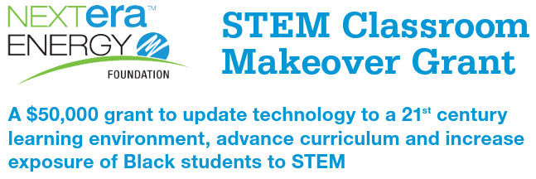 Vide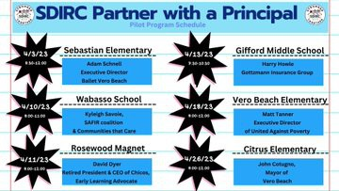

https://youtu.be/x9k0QMID2F0
